Project Design Phase-II
Data Flow Diagram & User Stories

Date | 18th June 2026
Team ID
Project Name | Health Connect
Maximum Marks | 4 Marks

Data Flow Diagrams:
A Data Flow Diagram (DFD) is a traditional visual representation of the information flows within a system. A neat and clear DFD can depict the right amount of the system requirement graphically. It shows how data enters and leaves the system, what changes the information, and where data is stored.
Example: DFD Level 0 (Industry Standard)
Example: (Simplified)
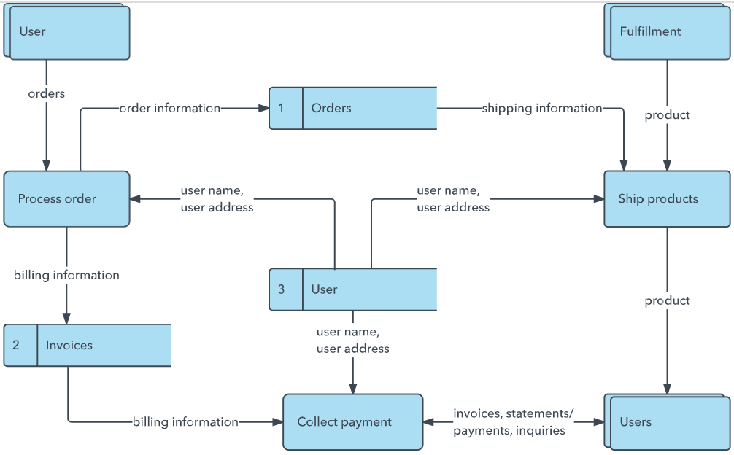


User Stories
Use the below template to list all the user stories for the product.
User Type | Functional Requirement (Epic) | User Story Number | User Story / Task | Acceptance criteria | Priority | Release
Patient | Authentication | USN-1 | As a patient, I want to register and log in securely so that my health data remains private. | Successfully login, access dashboard, see welcome message. | High | Sprint-1
Doctor | Authentication | USN-2 | As a doctor, I want to register with my credentials so that the platform can verify me. | Success register; pending verification status displayed on login. | High | Sprint-1
Admin | Doctor Management | USN-3 | As an admin, I want to verify pending doctors so that only certified professionals consult. | Approve button changes doctor verify flag; graphs update. | High | Sprint-1
Patient | Booking | USN-4 | As a patient, I want to book appointments for a specific slot and date. | Confirm booking shows consulting fees in INR, updates doctor queue. | High | Sprint-1
Doctor | Clinical Panel | USN-5 | As a doctor, I want to see my appointments and issue digital prescriptions. | Consult page saves diagnosis and prescription to DB. | High | Sprint-2
Patient | Medication Progress | USN-6 | As a patient, I want to track active prescriptions using interactive checkmarks. | Checking off a pill updates progress bar completion percentage. | Medium | Sprint-2
Patient | Health Locker | USN-7 | As a patient, I want to upload files and view a chronological health timeline. | Timeline shows file uploads in order of date. | Medium | Sprint-2

